**Create Azure Devops Environment and configuring Azure Devops Git Repository ,configure on your local git to implement this upload few test files on same.**

After logging in to the azure portal, we need to search and open the azure devops organisations

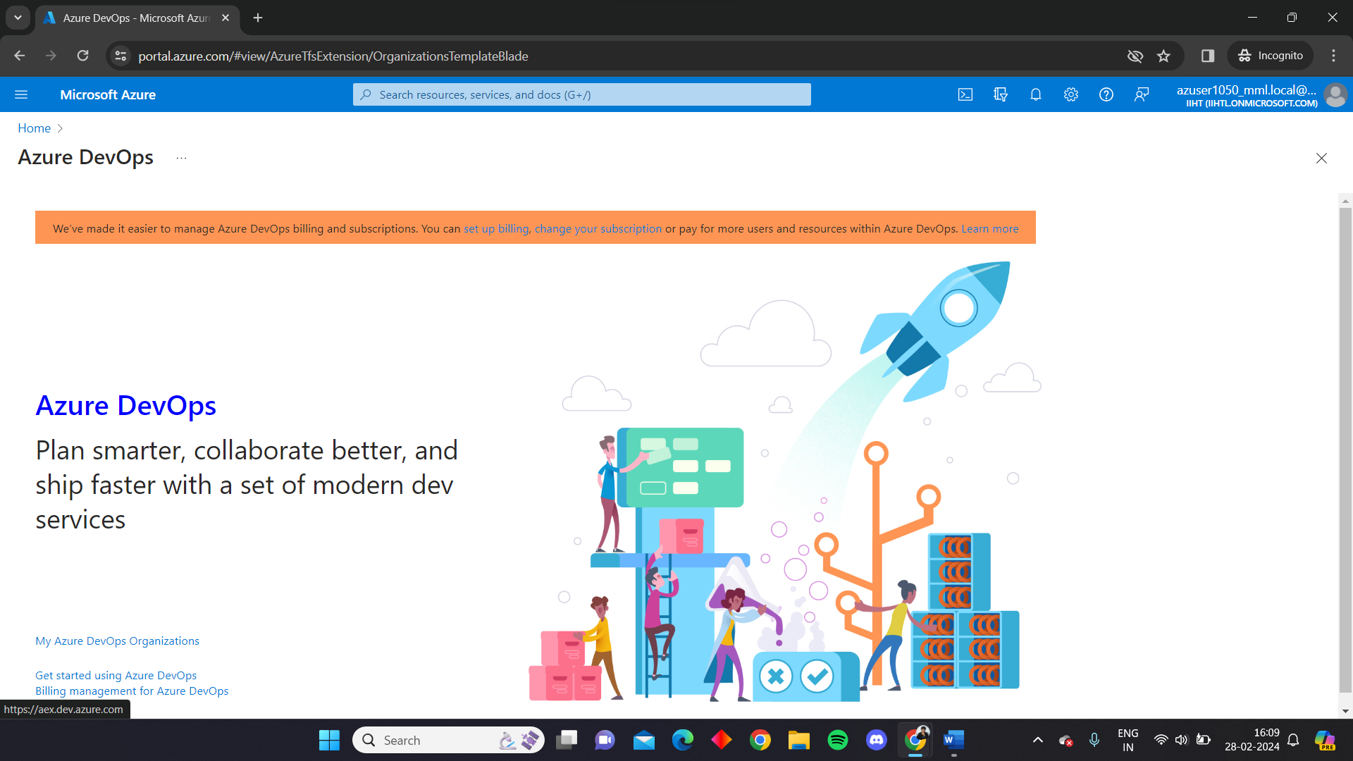

We should click on My Azure Devops Organisations

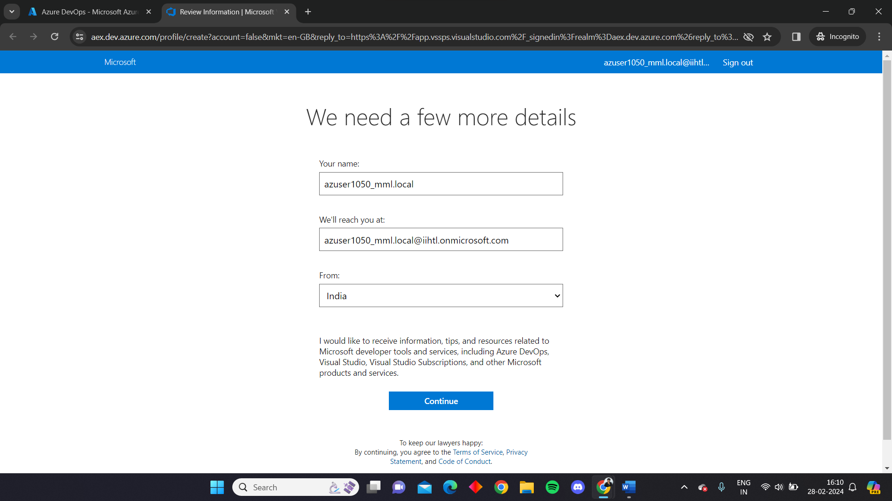

Then we need to create new organisation

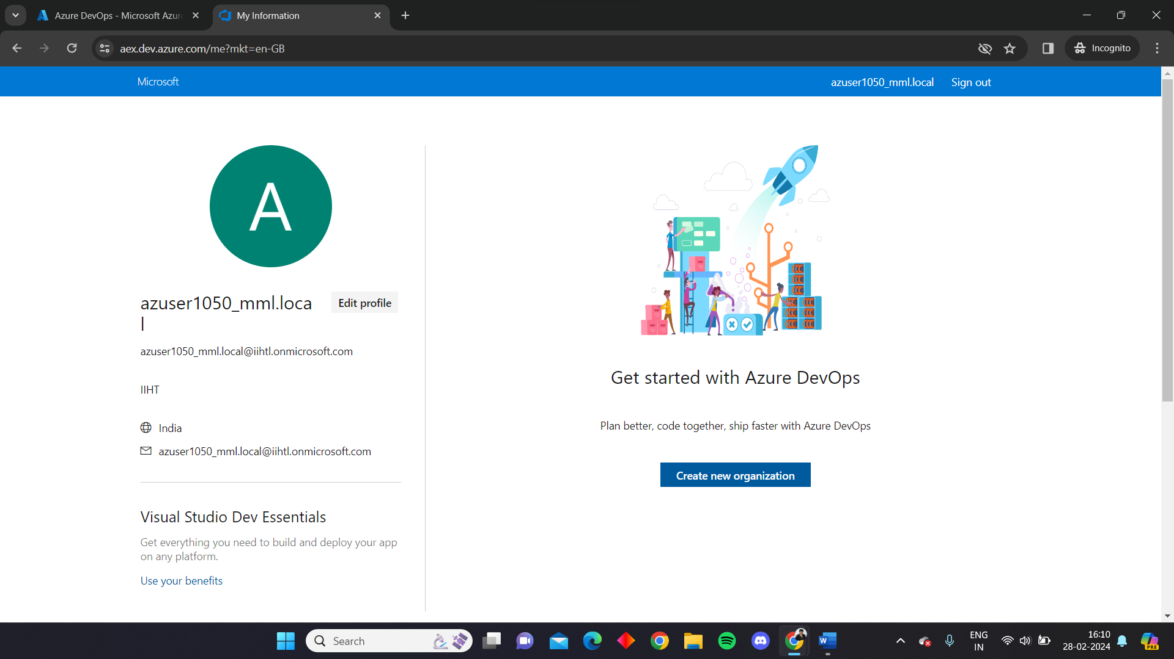

We need to provide the essentials and the right credentials for creating a devops organisation

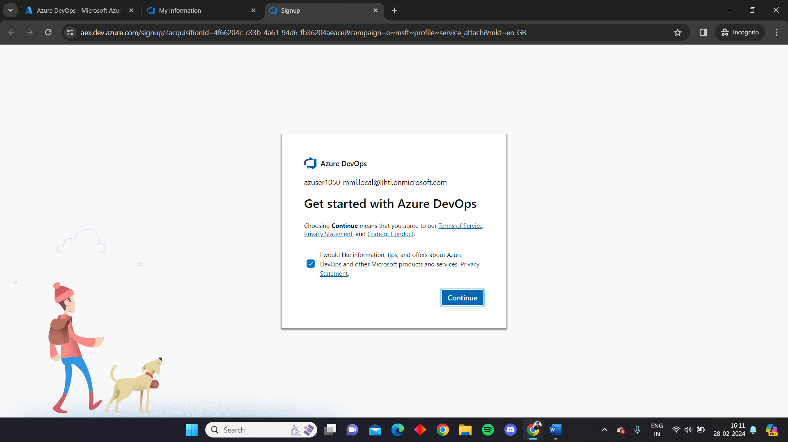

After successfully creating we need create a new project, we are naming it coding_challenge here

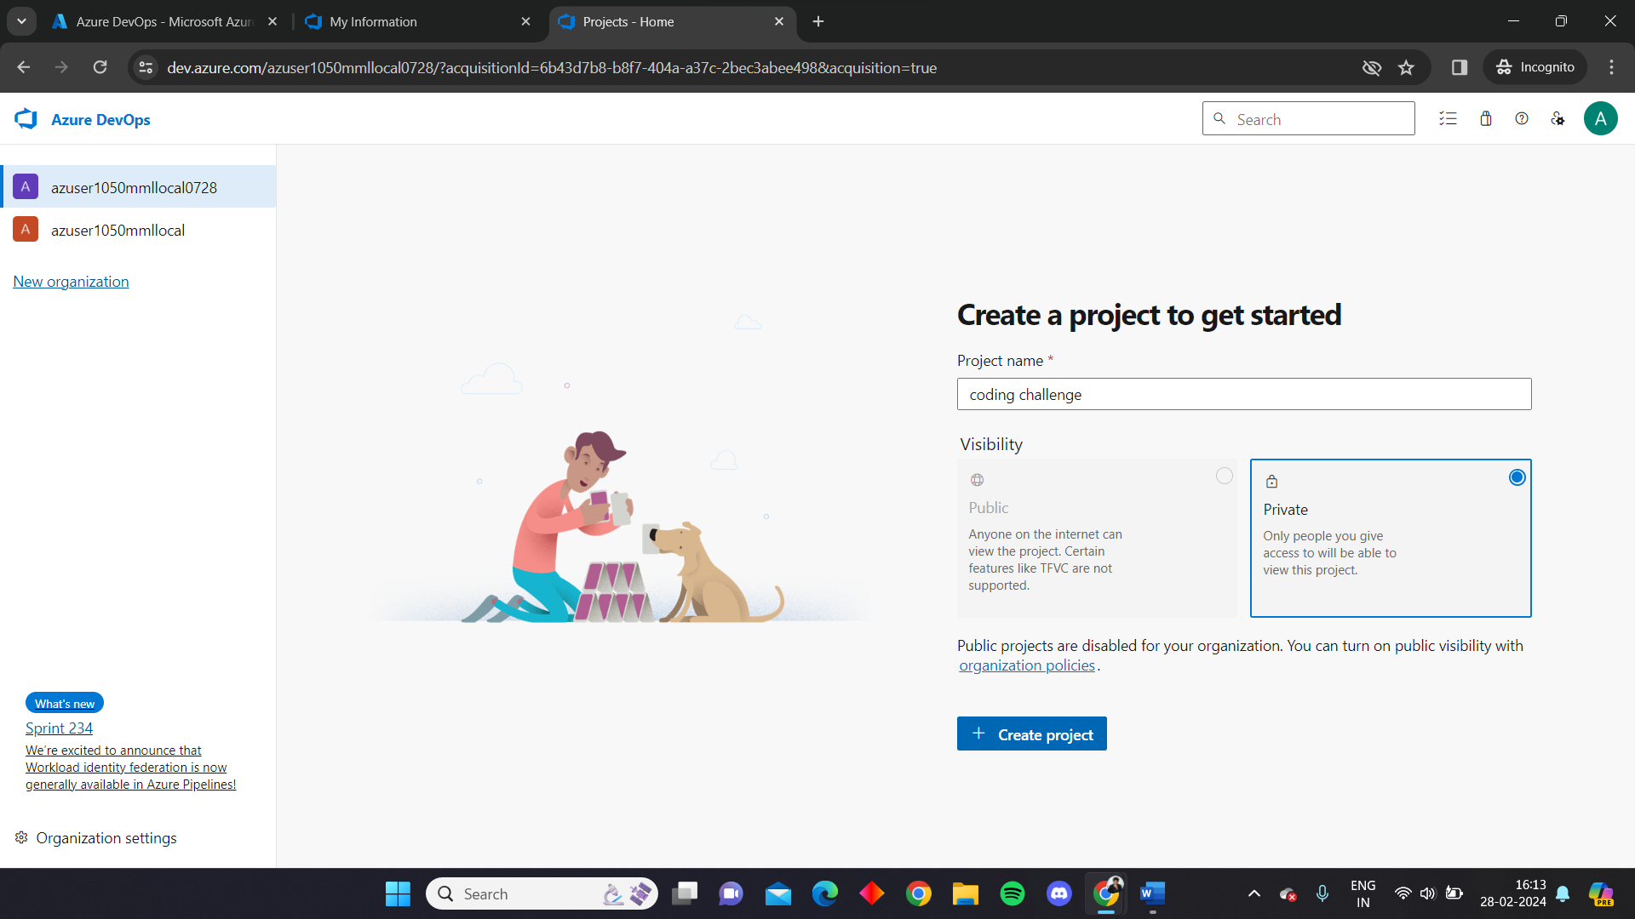

After creating the Azure Devops environment, go to repos on the left side and copy the link to clone the repo on your local

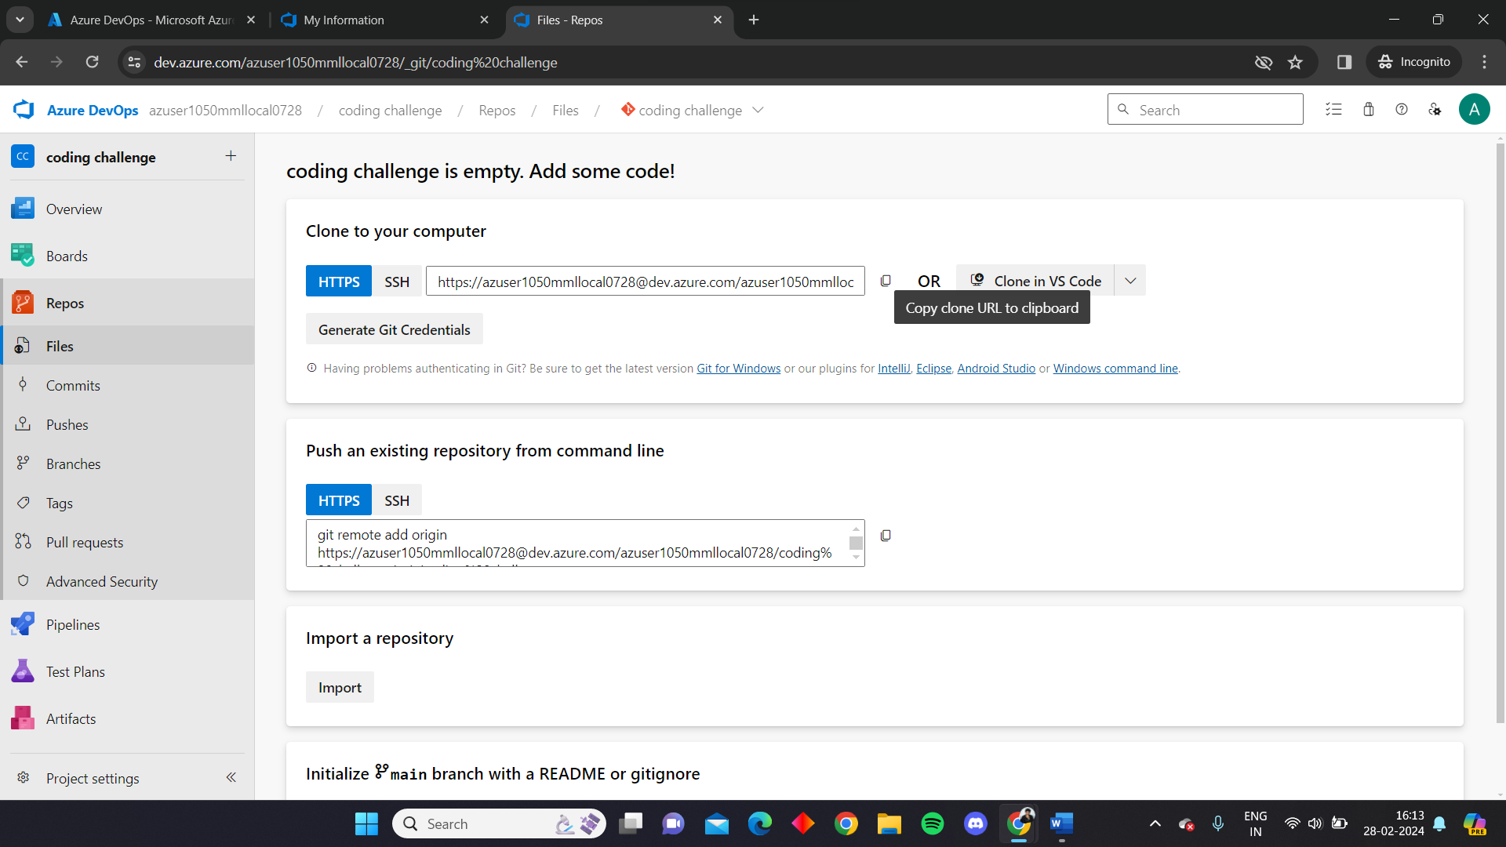

Open git bash and run the command “git clone” along with the copied url

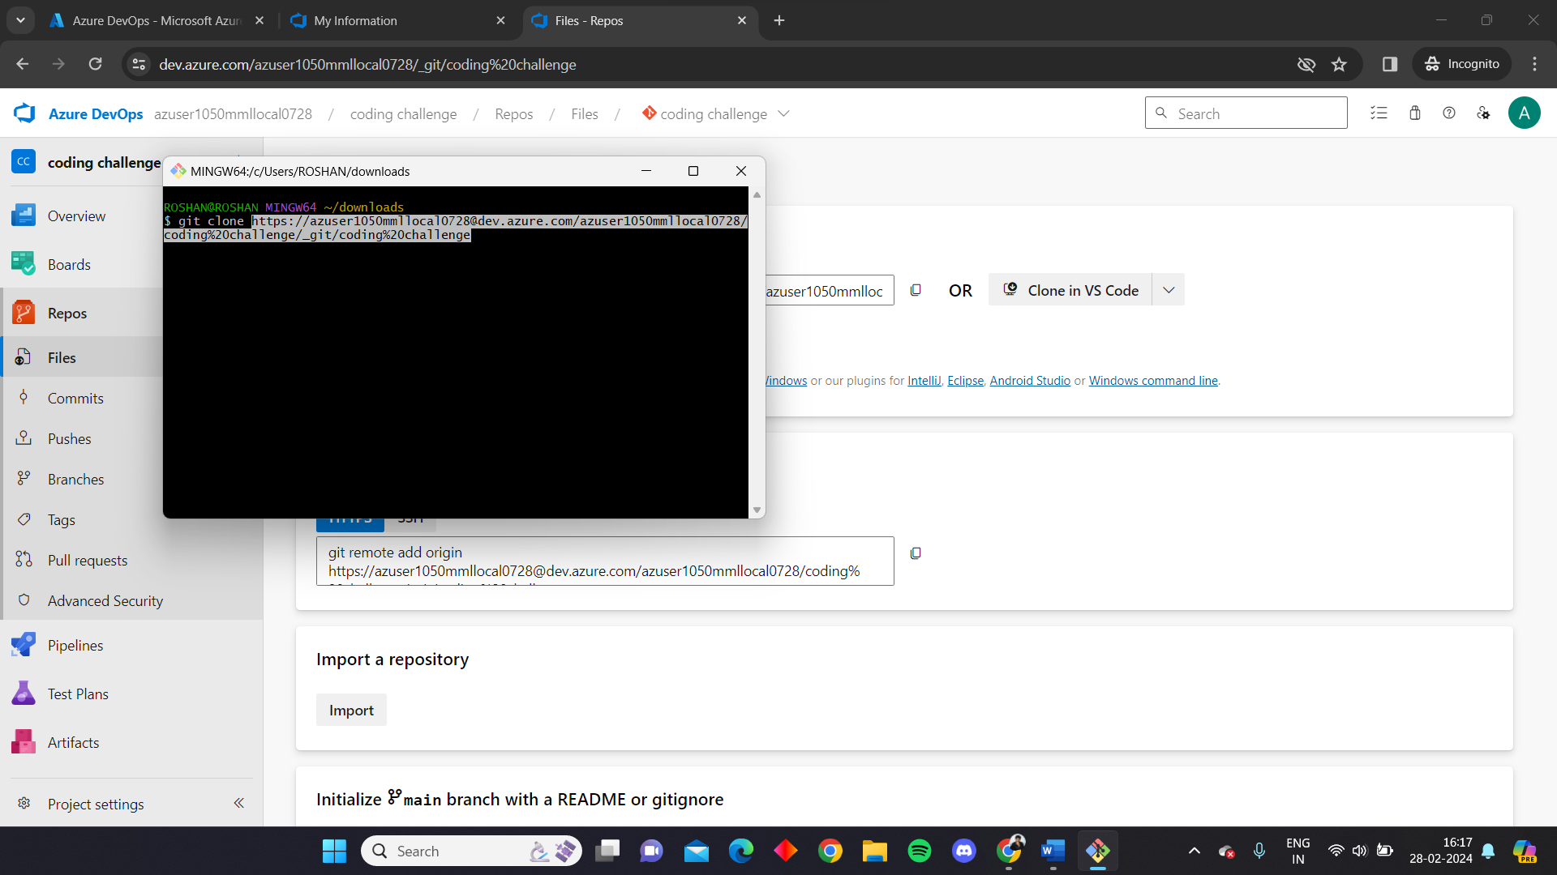

Provide the necessary credentials on your local to authenticate and connect with the devops

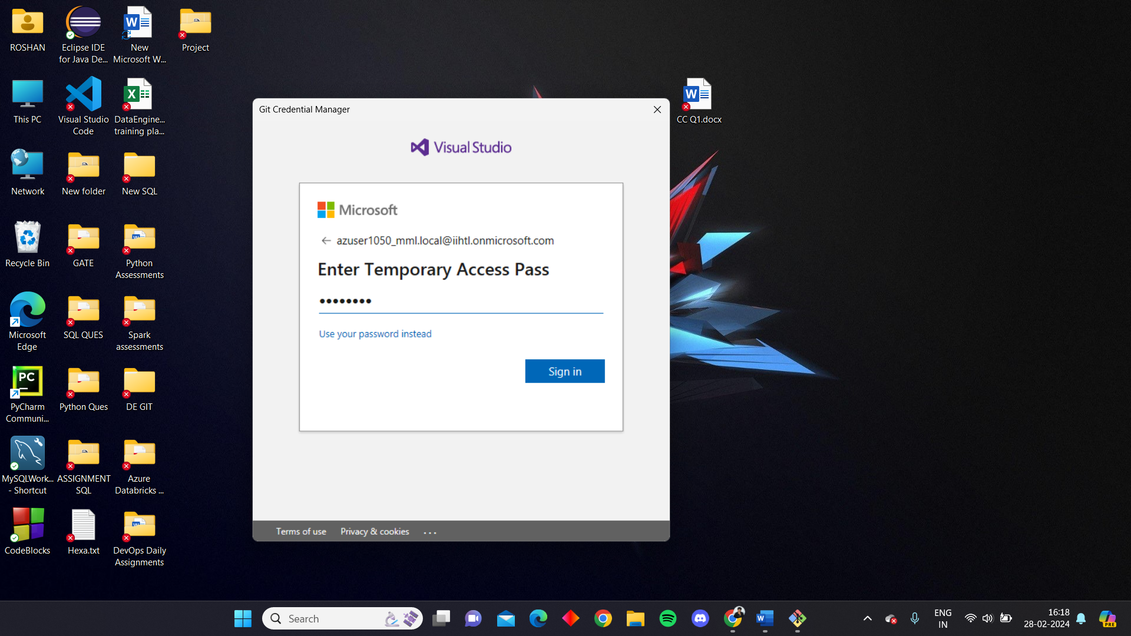

After giving the essential credentials you can see that the coding challenge repo that was created in devops organisation has been copied to local in the mentioned path

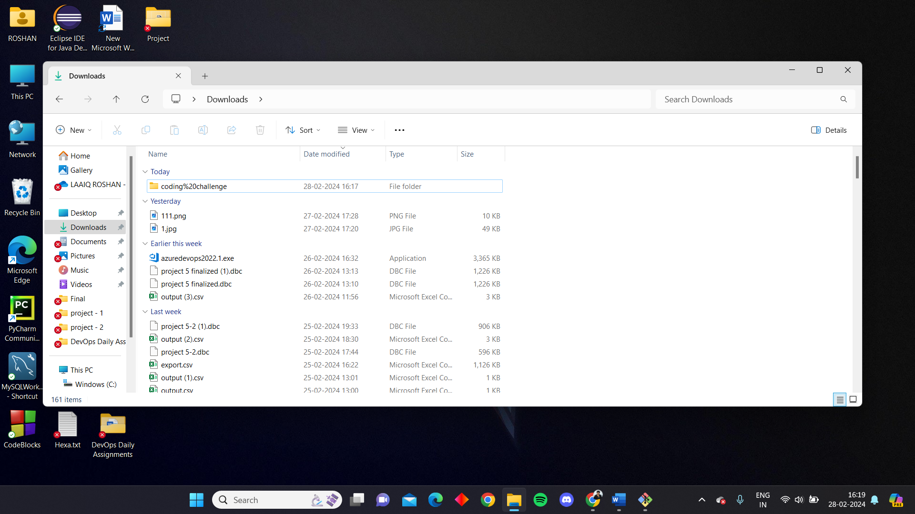

We can see the .git file in it. To perform push operation we are uploading a sample .docx file in the local cloned repo

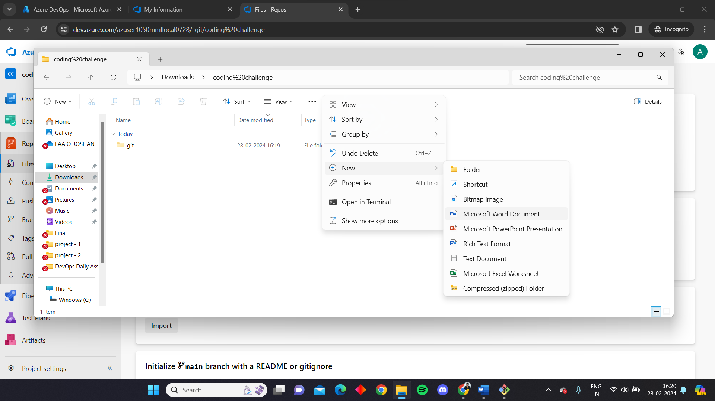

To add the file to the staged area we need to go to the repo path and give ‘git add .’ command to add the files

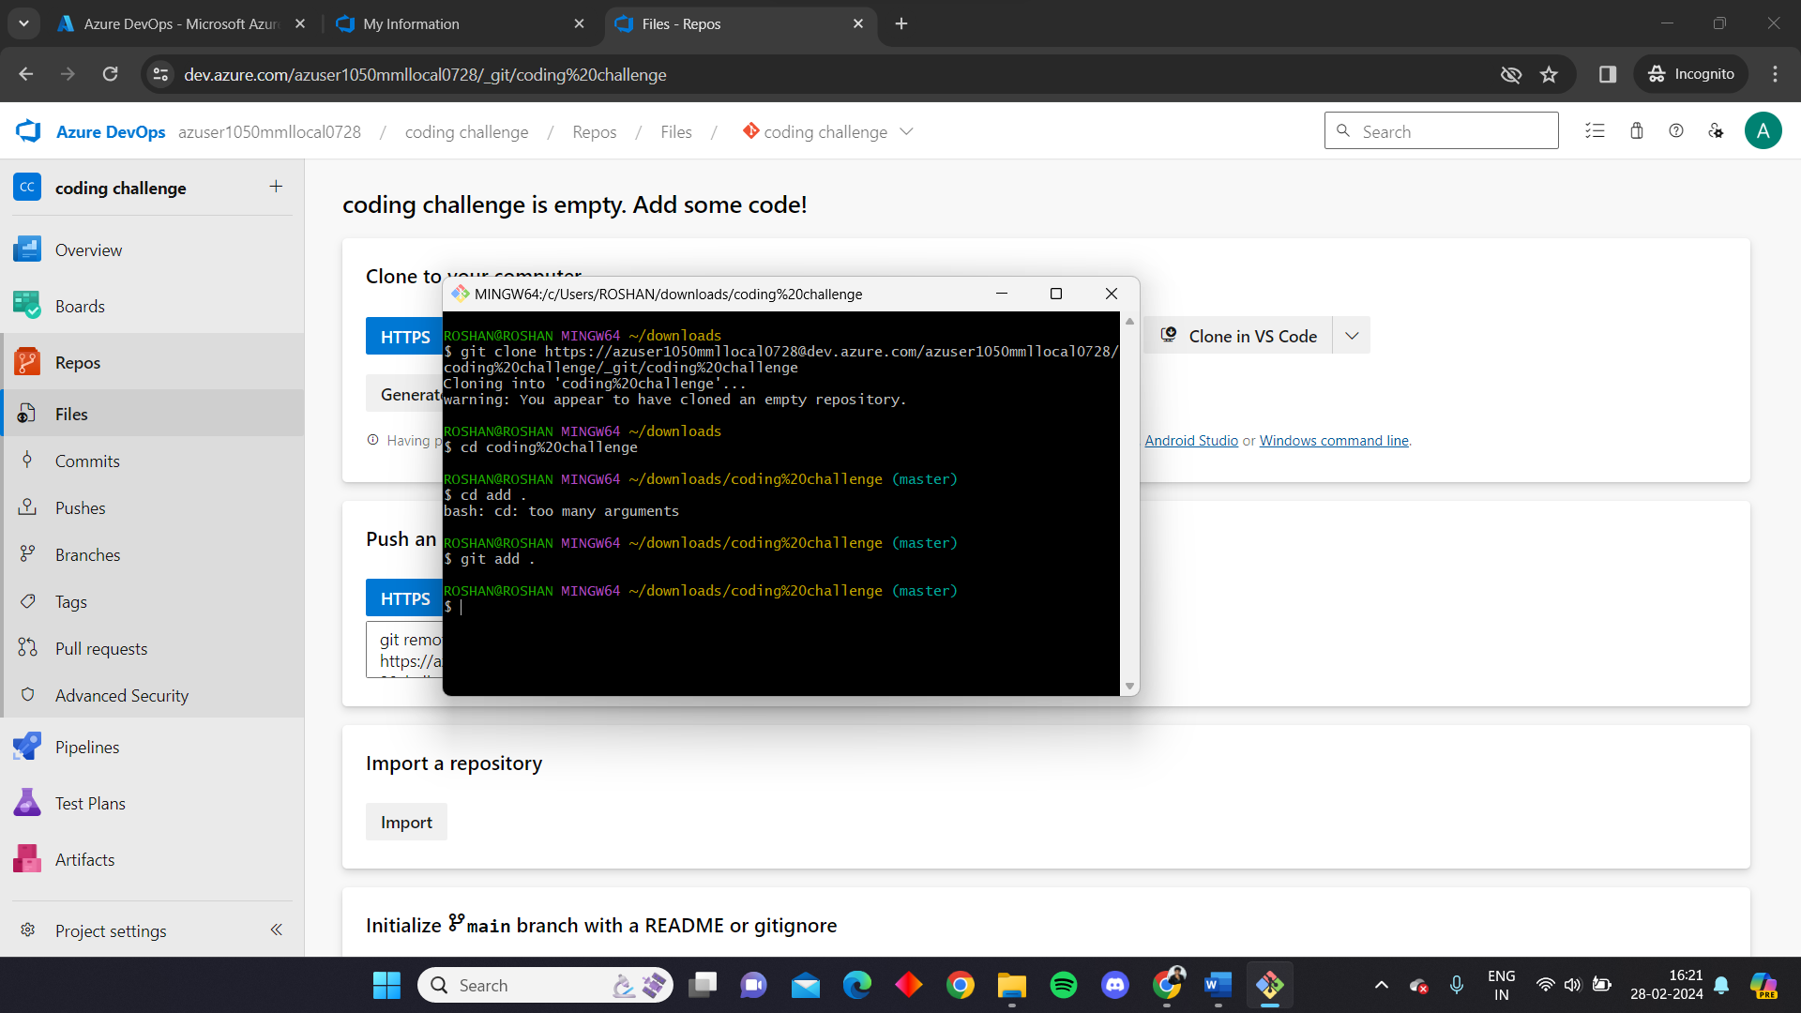

Upon giving the git commit command the files will be moved to the staged area. We are naming this commit as ‘first’

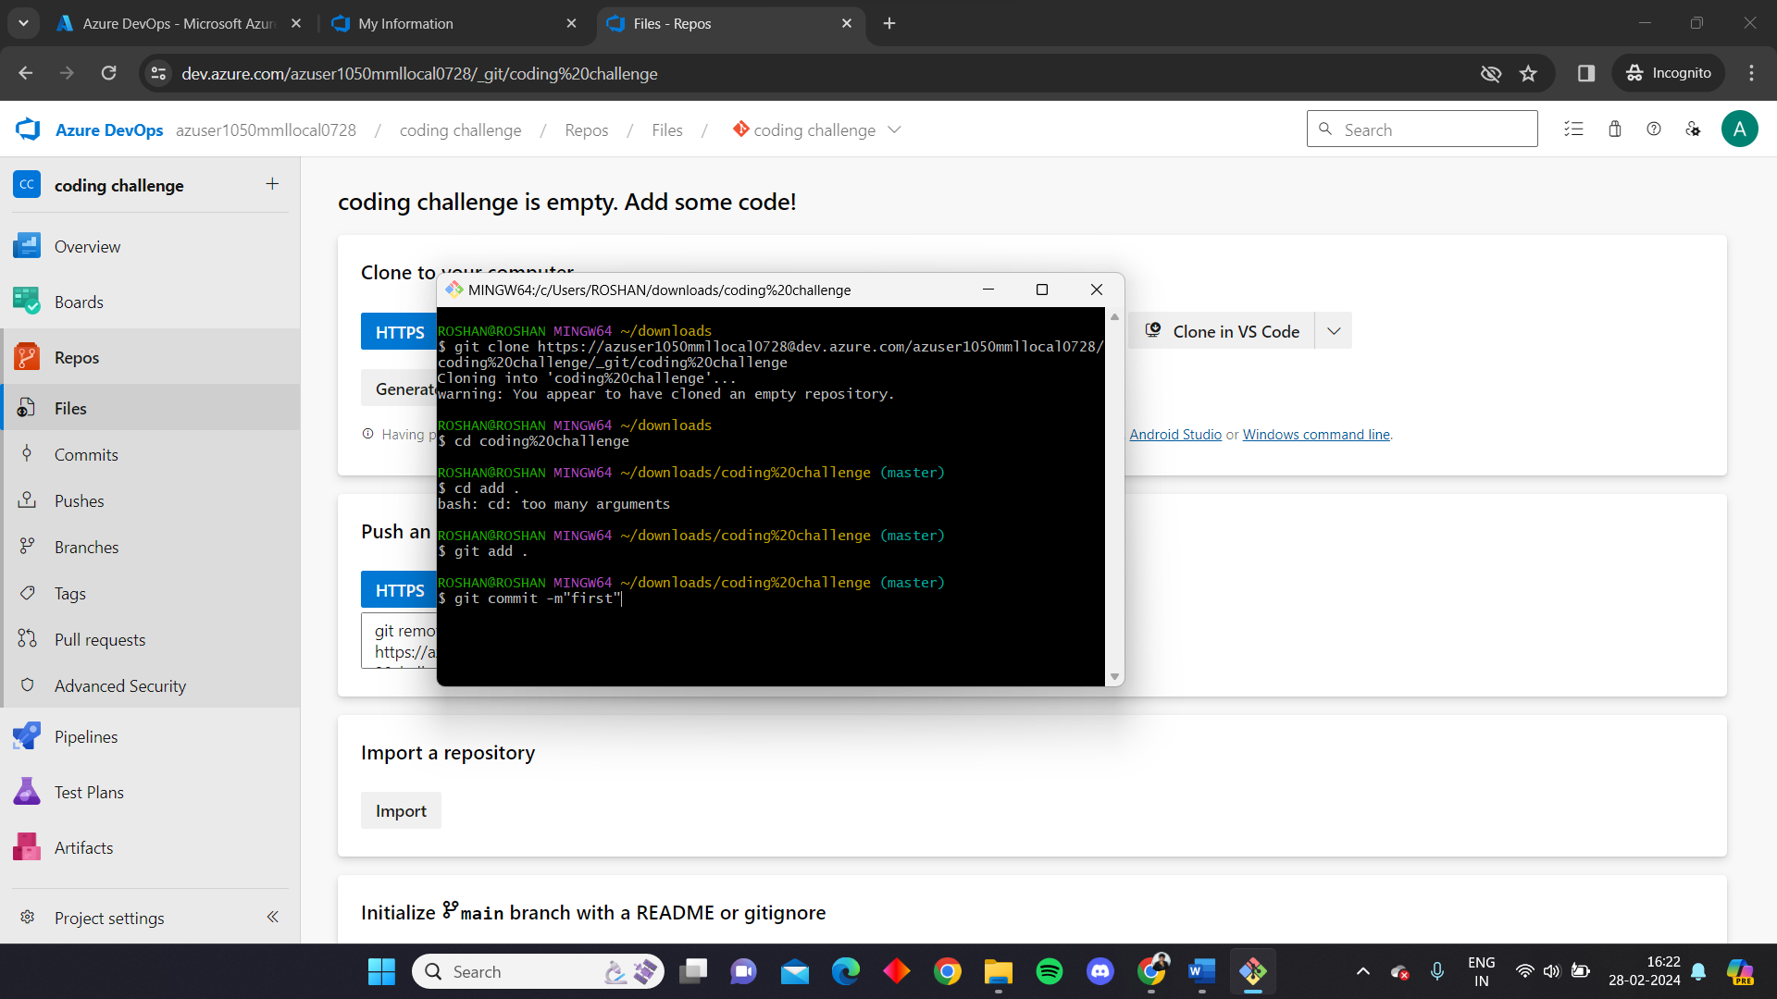

By giving the ‘git push’ command all the files in the staged area will be pushed to the git repo

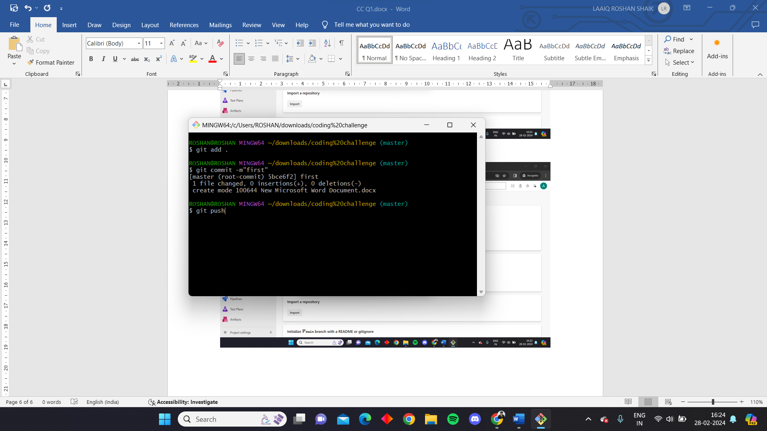

We can see git operation is completed

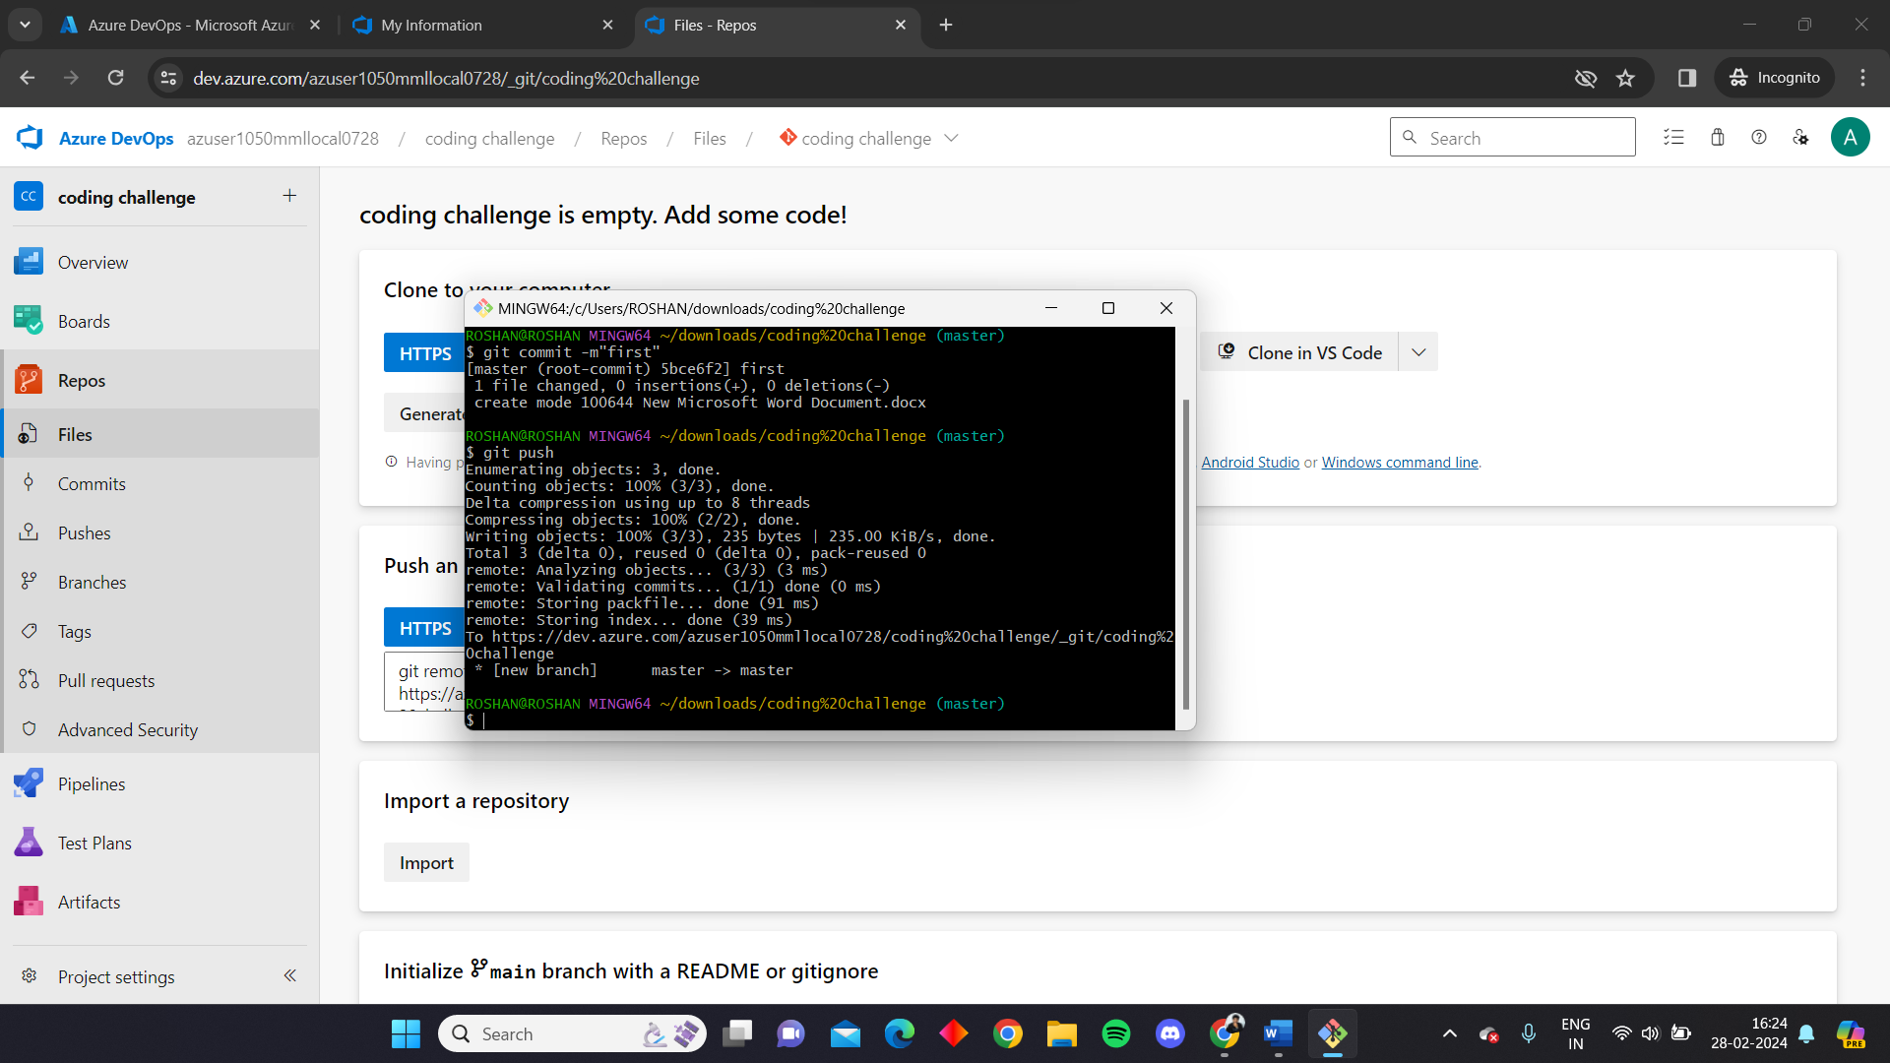

Here we can see in the git repo the file we created in local is present which is pushed from the local by git push command.

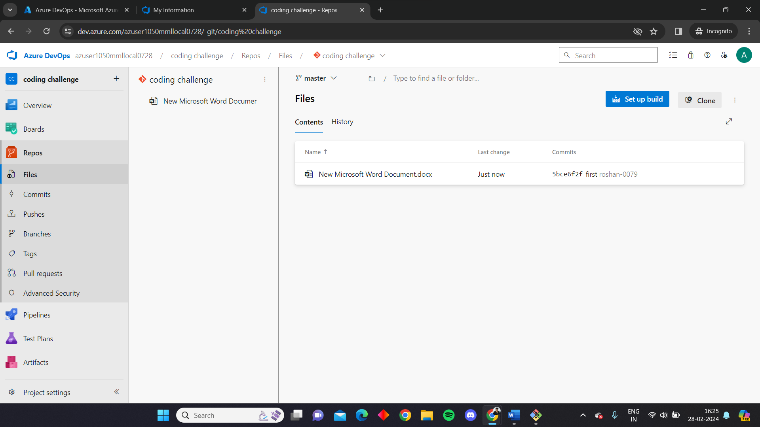

Now to perform a pull operation we are creating a file in the git repo naming it as for_pull

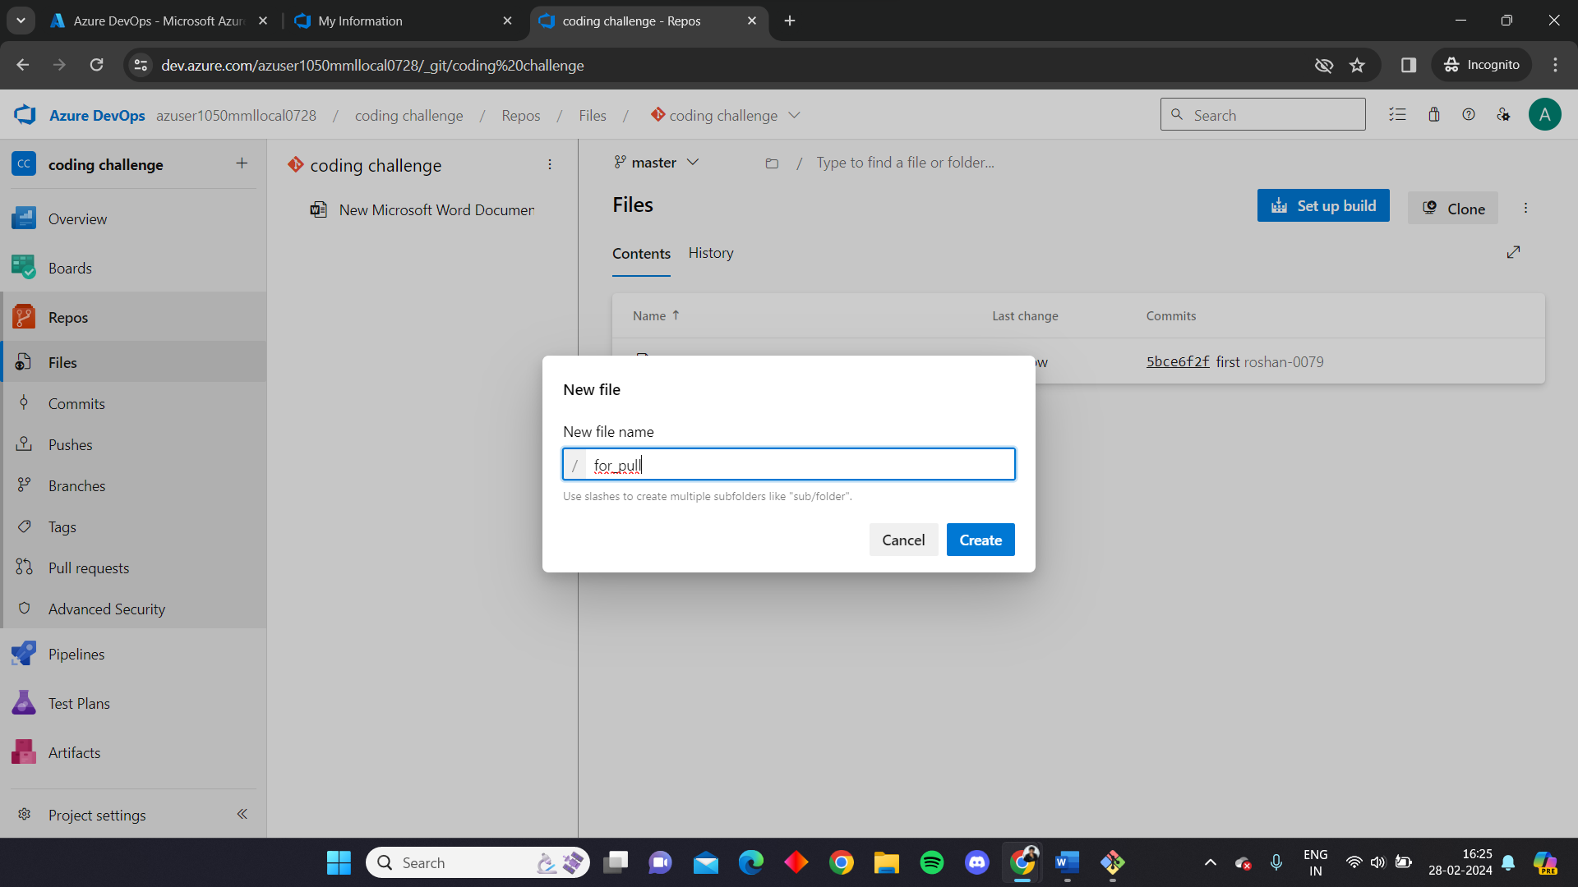

The file contains the following message

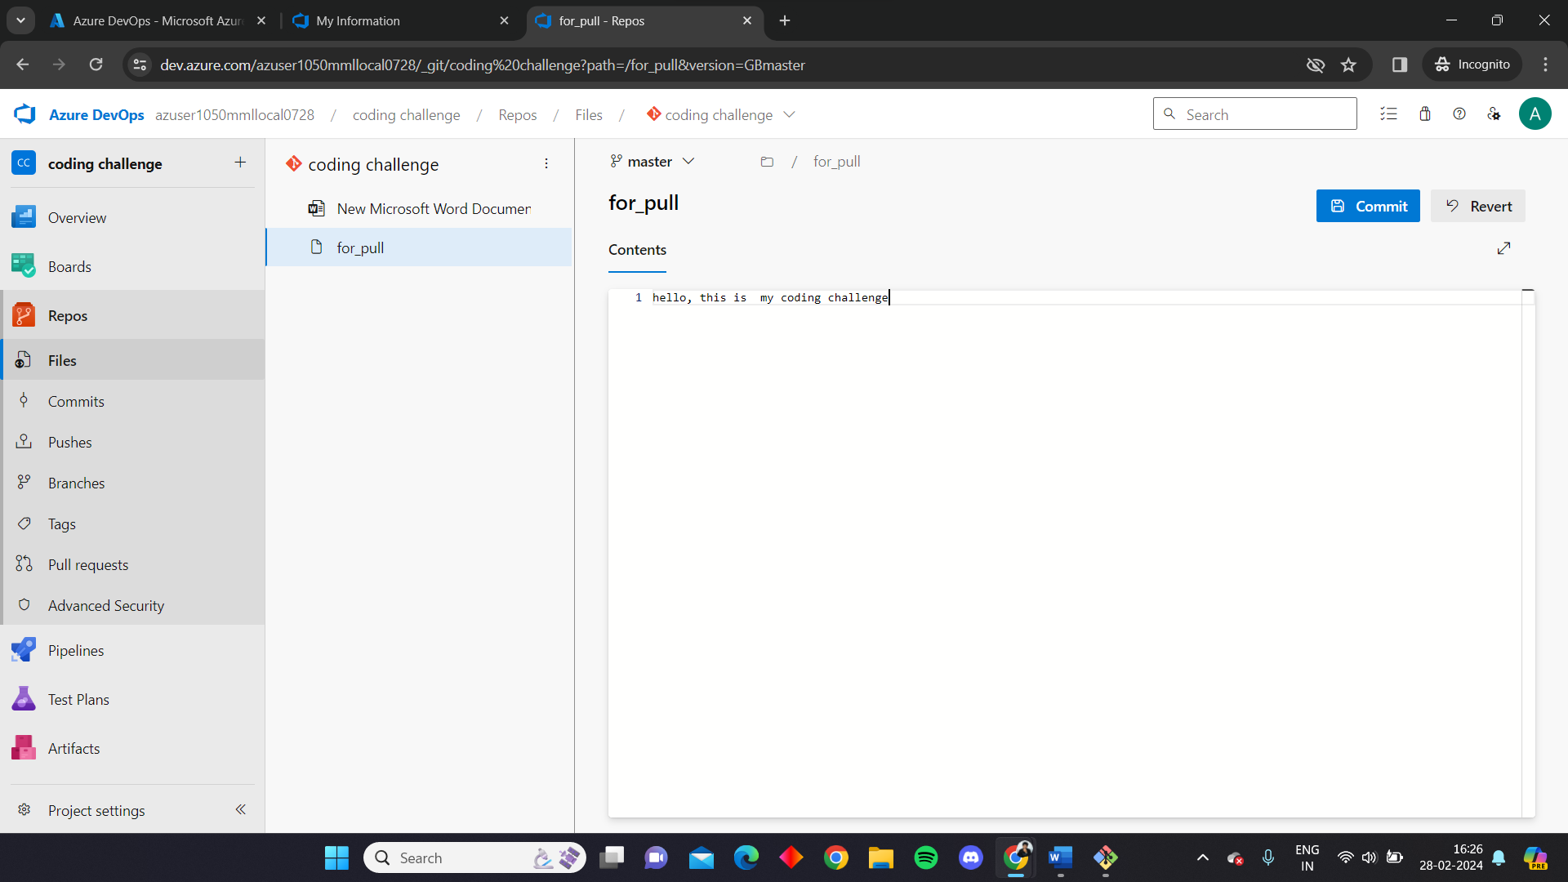

Now in the local git bash we give a command “git pull” which pulls the files in the repo to local

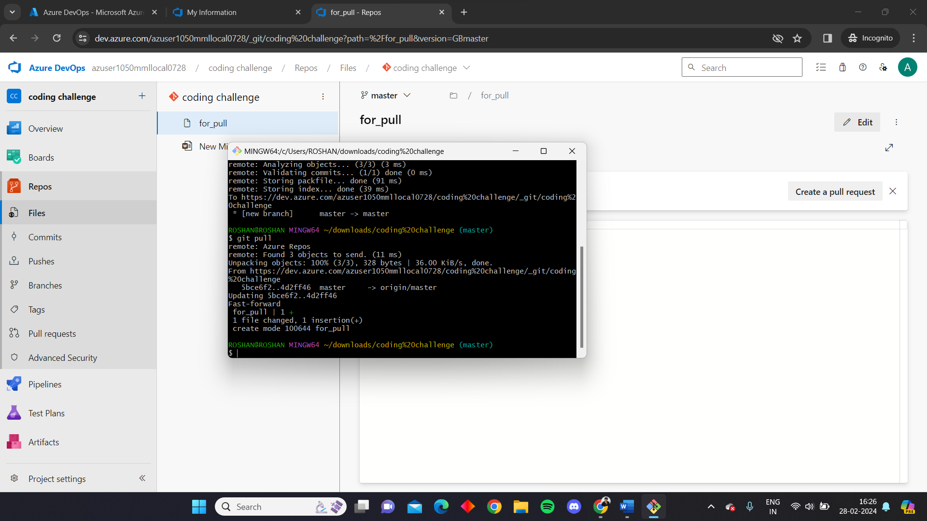

We can see the file ‘for_pull’ has been pulled in the local repo

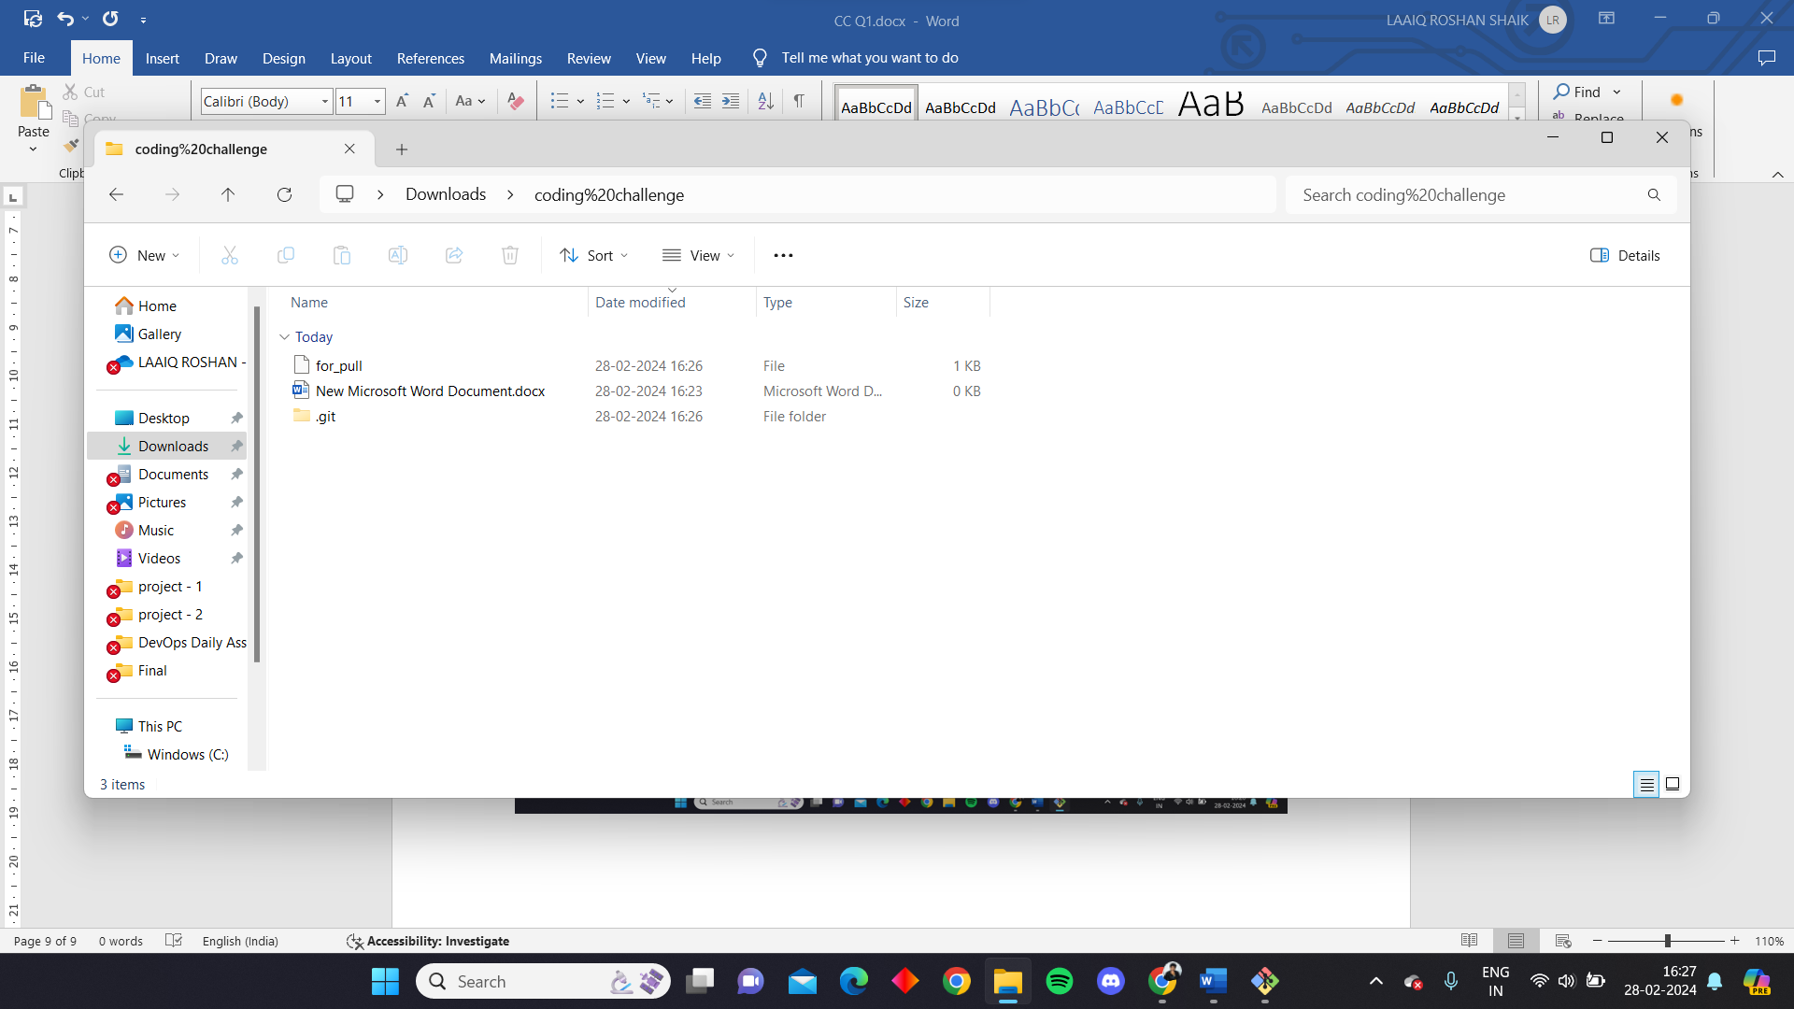

We can also see the message by opening the file

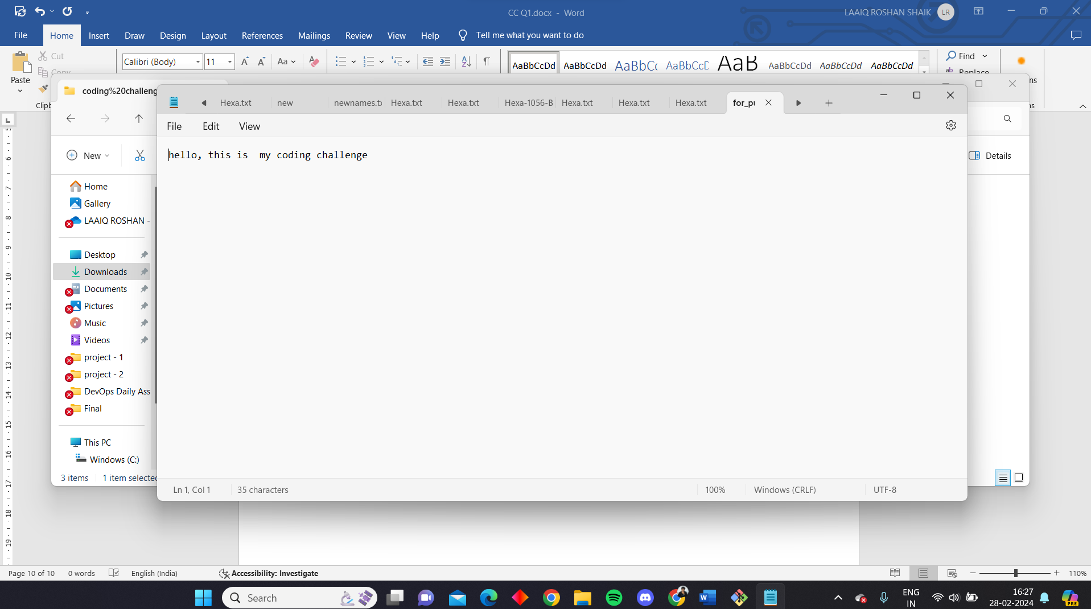

Here you can see the list of commits that are performed

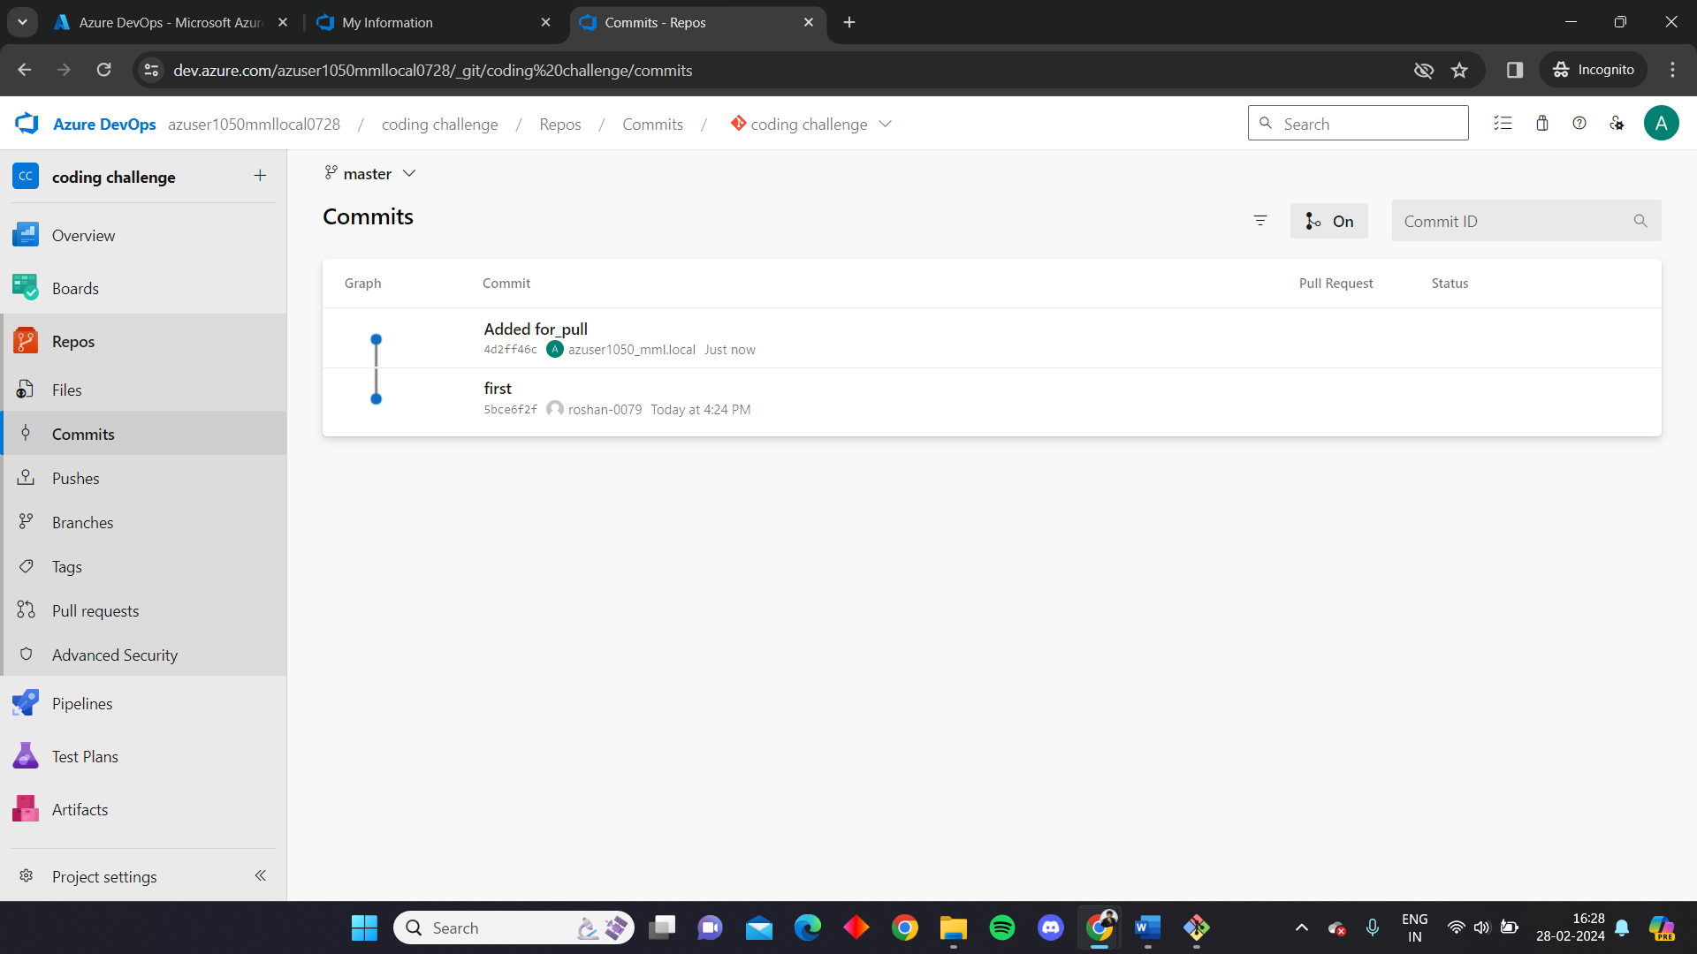

Likewise we can create git repo in Azure by using Azure devops and integrate it with local git to handle the repository and perform the operations.